**EXPERIMENT – 1**

**AIM -** Perform an experiment on data cleaning.

**Description –**

Data cleaning is one of the important processes involved in data analysis, with it being the first step after data collection. It is a very important step in ensuring that the dataset is free of inaccurate or corrupt information. Data cleaning is the process of modifying data to ensure that it is free of irrelevances and incorrect information. Also known as data cleansing, it entails identifying incorrect, irrelevant, incomplete, and the “dirty” parts of a dataset and then replacing or cleaning the dirty parts of the data. Data cleansing is very important to companies, as lack of it may reduce marketing effectiveness, thereby reducing sales. Although the issues with the data may not be completely solved, reducing it to a minimum will have a significant effect on efficiency.

Some methods to clean data –

1. You can ignore the tuple.This is done when class label is missing.This method is not very effective , unless the tuple contains several attributes with missing values.
2. You can fill in the missing value manually.This approach is effective on small data set with some missingvalues.
3. You can replace all missing attribute values with global constant, such as a label like “Unknown” or minus infinity.

4. You can use the attribute mean to fill in the missing value.For example customer average income is 25000 then you can use this value to replace missing value for income.

5. Use the most probable value to fill in the missing value.

Python code for Cleaning Data–

1. import pandas as pd

df=pd.read_csv('missing.csv')

print(df)

Output-

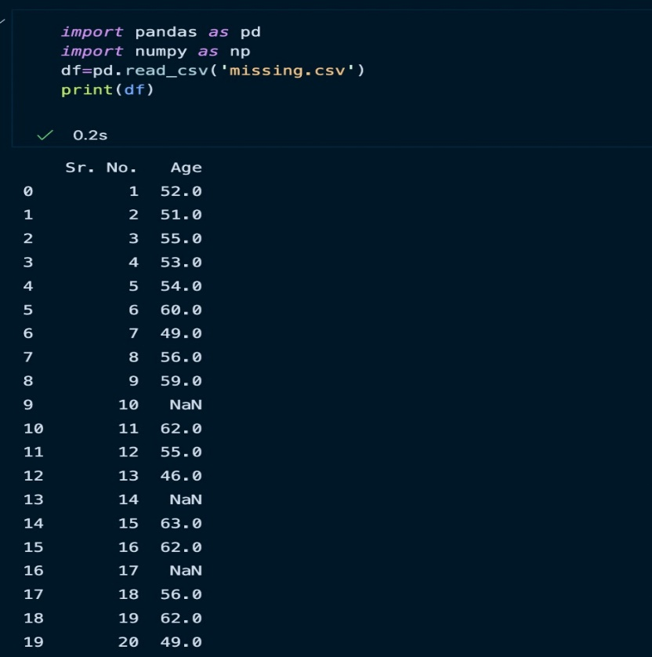

1. new_df=df.fillna(np.mean(df))

print(new_df)

Output –

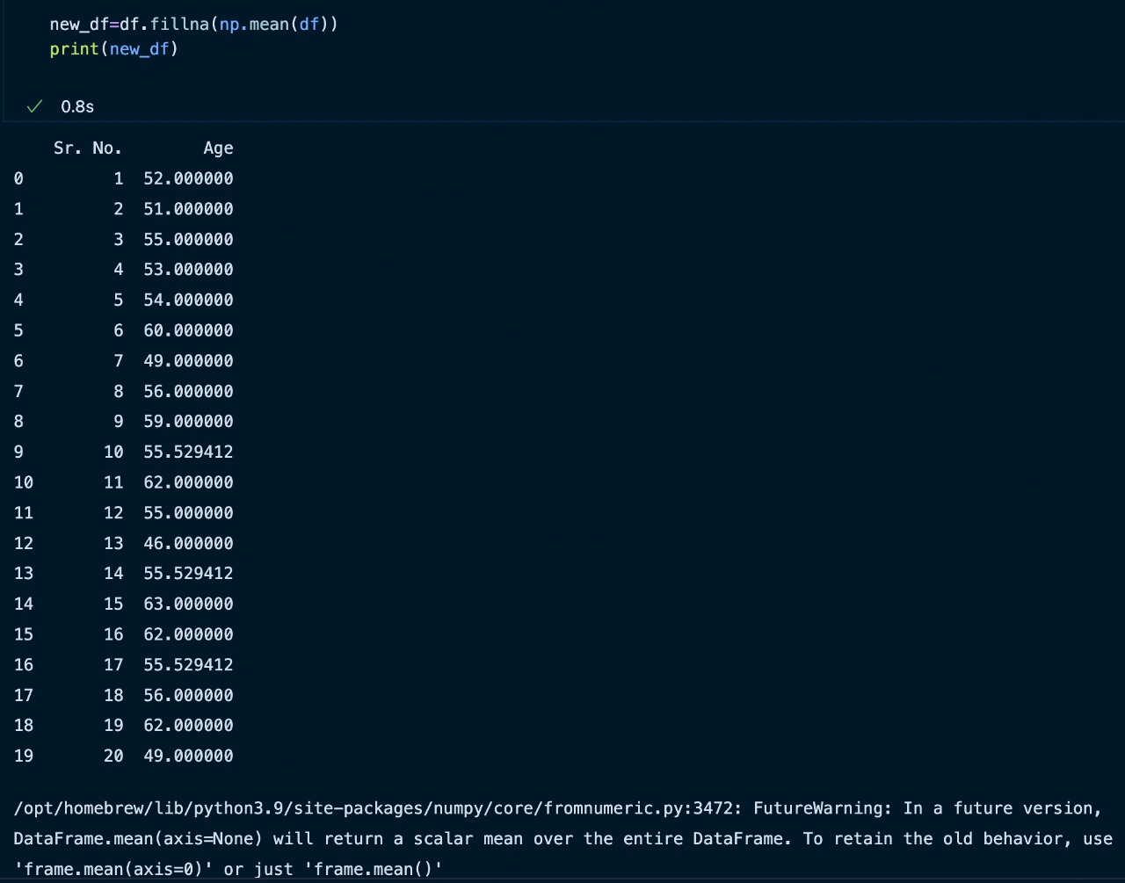

1. df=pd.read_csv('missing.csv')

print(df)

new_df=df.fillna(0)

print(new_df)

Output –

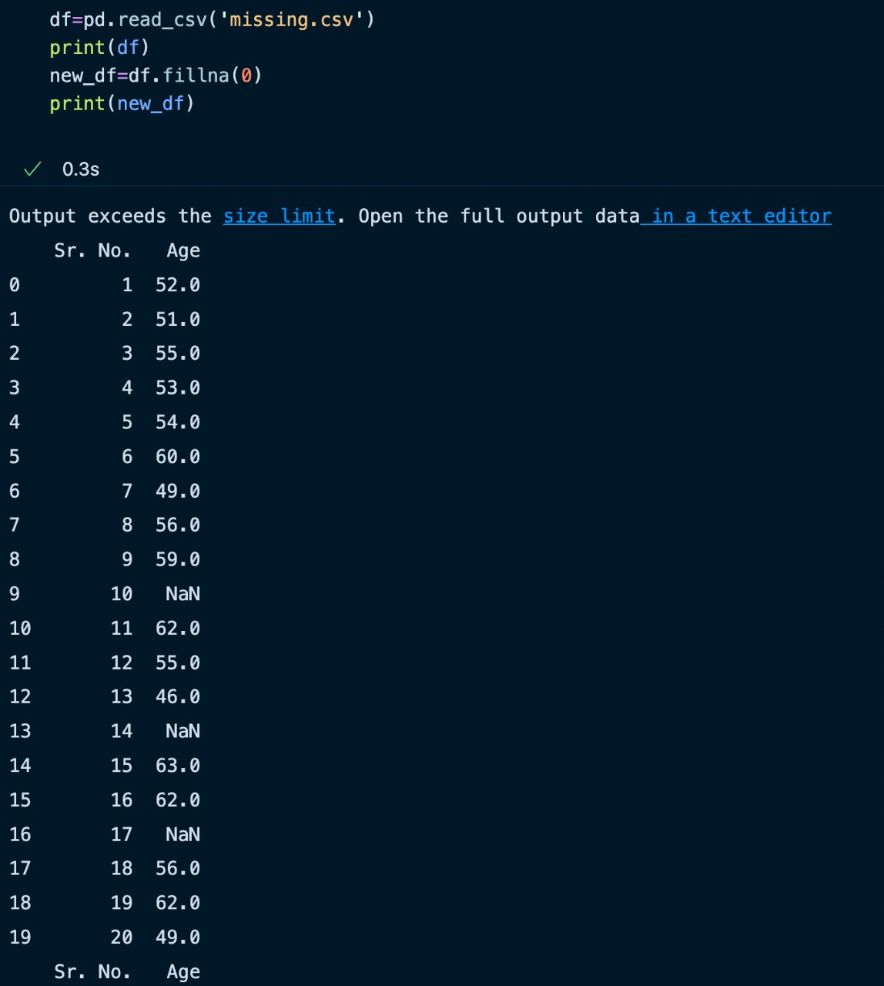

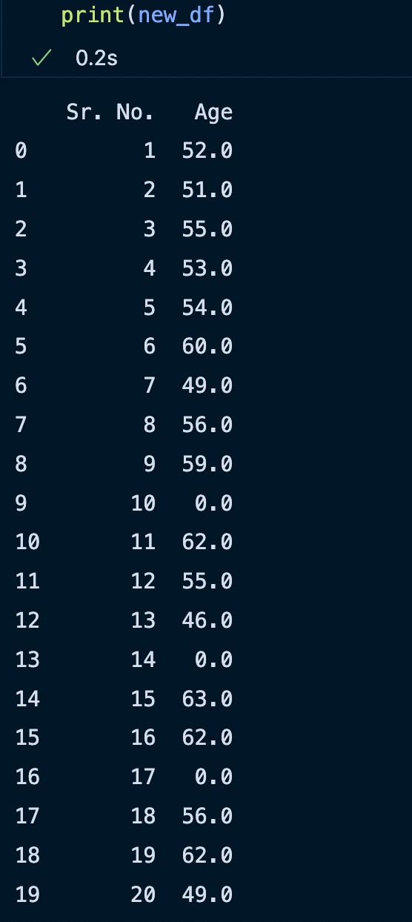

1. help(df.fillna)

Output –

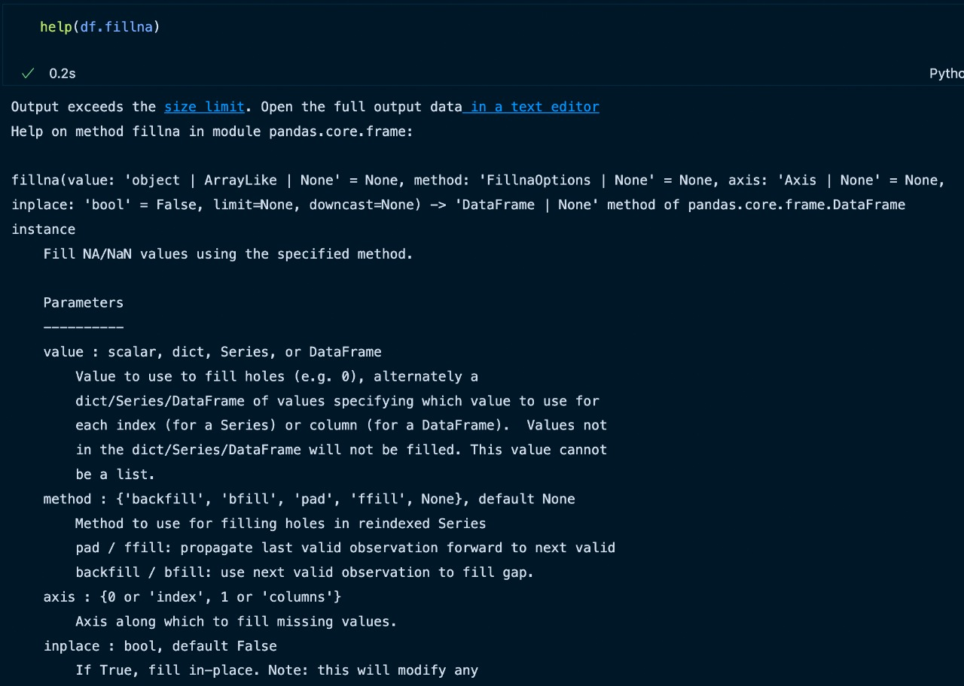

1. df=pd.read_csv('missing.csv')

print(df)

new_df=df.fillna(method='backfill')

print(new_df)

Output –

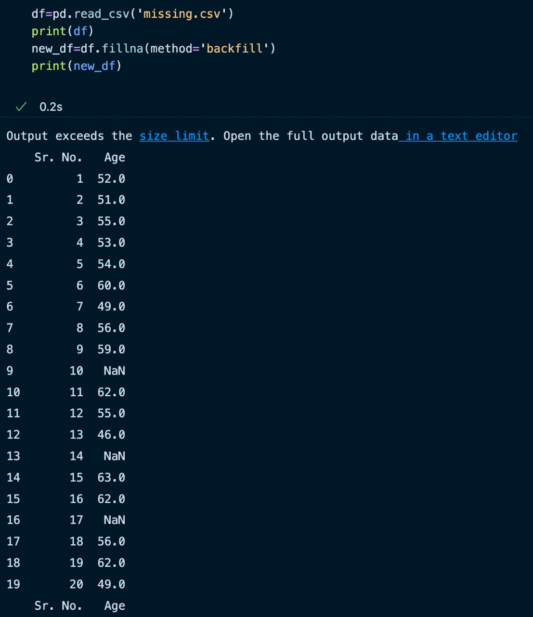

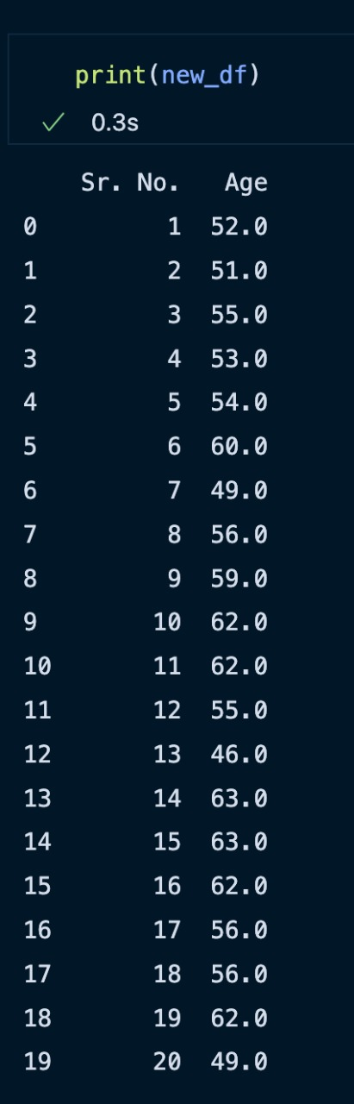

**EXPERIMENT – 21**

**AIM –**

Write a prolog program given the knowledge base, If x is on the top of y, y supports x. If x

is above y and they are touching each other, x is on top of y. A cup is above a book. The cup

is touching that book. Convert the following into wffs, clausal form; Is it possible to deduce

that ‘The book supports the cup’.

**Description –**

In this prolog program, we have to find whether it is possible or not to deduce that ‘The book supports the cup’ with the help of the given knowledge base.

A cup is above a book.

above(cup,book).

The cup is touching that book.

touch(cup,book).

If x is on the top of y, y supports x. If x is above y and they are

touching each other, x is on top of y.

support(X,Y) :-above(X,Y), touch(X,Y).

Prolog Code-

:- initialization(main).

above(cup,book).

touch(cup,book).

support(Y,X) :- above(X,Y), touch(X,Y).

Input –

support(book, cup).

Output –

